Behavior Management Policy in F-3

Ms. Lowe

Our behavior management system for this school year is a clip chart. Each student will begin his/her day with their clothes pin on “Ready to Learn,” as they all should be when they enter the classroom. Based on their behavior they may be asked to move their clothes pin up or down the chart.

* Blue, Model Student, is a reward for their behavior and effort.
* Light green represents a warning to allow for students to correct their behavior with little consequence.
* Students on Orange will sit at a designated desk near the book shelf and take a break. There, the student will have three minutes (using an egg timer) to begin to fill out a reflection. The reflection form focuses on the description of the behavior, reasons for the behavior, and consequences of the behavior. 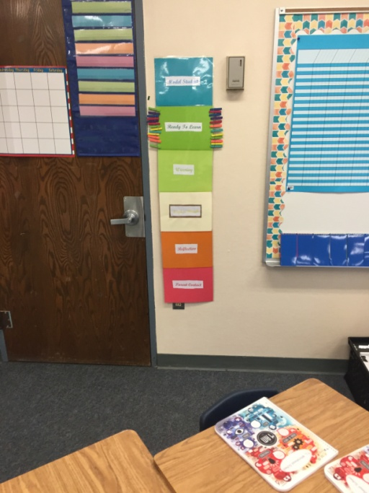After the three minutes, the student will complete the form on his or her own time. It is due the following day. Failure to return the form will result in a loss of recess time until the form is completed and turned in.
* On red, students will need to have the reflection form signed by a parent or guardian. Failure to have the form signed will result in the loss of recess until the form is brought back, signed. In addition, there will be a phone call/email placed to reach out to the parents regarding the student’s behavior.

Each student has a small calendar chart whereby they will shade the color which represents their behavior for the day and set an attainable goal for the following day.

Class Rewards- As a class, we will earn “points” in the form of marbles. We will begin with a full mason jar of marbles. When we, as a team are following SOAR rules (being safe, organized, attentive, and respectful) we will earn marbles in the SOAR jar. Once the jar is filled, we will have earned a class reward in the form of free time, or a class celebration.

Group Rewards- Groups will earn points for following SOAR in the classroom as well. Group points will be tallied on the whiteboard. Each Monday, the points will be counted for the previous week. The winning group will have access to the beanbag chairs in the library during SMR for the current week.

Individual Rewards- Students who follow SOAR will be rewarded with a Caught Being Good slip. They will take this slip to the office and, at the end of the week; they will be able to choose a prize from the student “store” inside the office.

Homework Policy

Homework this school year will be a combination of WEEKLY ELA homework and DAILY math homework.

* Each student will receive a packet of ELA homework which may consist of reading passages, vocabulary, and spelling. The packet will also include a reading log. Each student is required to read a minimum of 30 minutes each night and record this in their reading log. A small summary or response to their reading each night will be assigned as per the reading log. This packet is to be completed and returned each Friday morning.
* Homework in the mathematics subject area will be assigned daily. The intention of the assigned work is to give the student time to practice the skill/skills taught from the previous lesson. Upon turning in their homework students may write the number of any problem which they found challenging on the whiteboard. As a review, we will discuss, and solve the problems together as a class.

Students are given clear expectations on how and when to complete their homework. It is for their benefit to come to class prepared and to practice newly learned skills at home or in ASES. Students who do not complete, or turn in their work on time will complete it during their recess.

Thank you for your continued support in helping me to provide your child with a positive and consistent learning environment.

Student Signature_________________________________

Parent Signature__________________________________